12 March, 2020
Dear President,

INFORMATION REGARDING APPLICATIONS FOR THE 2021 NYSF YEAR 12 PROGRAM
Thank you to yourself and your club for the support you provided to students and the National Youth Science Forum (NYSF) throughout the January NYSF 2020 Year 12 Program. Rotary Australia plays a key role in enabling students across the nation to pursue their passion in STEM and connect with hundreds of likeminded people.
I am writing to encourage your club to support all year 11 students who approach you seeking endorsement for their applications to attend the National Youth Science Forum (NYSF) Year 12 Program in January 2021 – Australia’s only science, technology, engineering and mathematics (STEM) outreach program that reaches communities all over the country, thanks to our relationship with Rotary.
In 2021, nearly 600 places will be on offer. Attending NYSF is a unique opportunity for Australian students interested in STEM and related disciplines. Applications are open from early March to the 20 July (we have extended the closing date due to the later opening) to students currently in Year 11. While on the program, participants will experience 10 days packed with STEM related activities and talks from top scientists. The program is designed to encourage continued study in these fields and an awareness of careers that are critical for Australia’s future.

In 2021, the program will run at the following dates and locations:
Session A – Mon 4 – Wed 13 January 2021 – The Australian National University, Canberra
Session B – Mon 11 – Wed 20 January 2021 – The University of Queensland, Brisbane
Session C – Mon 18 – Wed 27 January 2021 – The Australian National University, Canberra

Application Process
Students must apply through the NYSF website www.nysf.edu.au. There is a $65 application fee, which covers the administrative cost of the NYSF selection process. This non-refundable fee is paid after the student receives endorsement from a Rotary Club. Students must submit their application by 20 July, so please endorse all applicants in a timely manner – there is no limit on the number of applicants your club can endorse. Similarly, there is no obligation to provide funding along with endorsement to those applicants who are successful.

Program Fee
The fee to attend the NYSF 2020 Year 12 Program is $3,250. Please advise students from the earliest time possible of the level of funding your club can provide, ensuring all parties (including parents) are aware of any financial obligations incurred by taking part in the program. Any financial or fundraising assistance your club can provide to successful applicants is greatly appreciated.
Funding Assistance
NYSF may be offering scholarship and funding opportunities for applicants thanks to our funding partners. Applicants will be informed of available funding opportunities and will be encouraged to apply if suitable to them.

Scholarships and funding are awarded as a reduction in the program fee, rather than being paid directly to the successful candidate or club. Further details will be promoted on the NYSF website.

Further funding may also be available through the “Inspiring Australia–Science Engagement Programme”. Further information is available at https://www.business.gov.au/assistance/inspiring-australia-science-engagement/student-sponsorship. Please note that at the time of writing this letter, applications for this funding are closed. Should they open again in the new financial year, successful applicants for the NYSF may apply. The funding is currently not available to individuals – only organisations, such as Rotary. Please direct any questions about this funding to the relevant government department.

NYSF Contacting your Club
When students apply, we will be encouraging them to provide their endorsing Club’s contact details, particularly an email address. We will always be willing to send hard copies of brochures as handouts for schools or meetings but are aiming to move all other communication to email rather than post, due to the significant cost of postage. We also ask that Club’s provide their correct email address to nysf@nysf.edu.au, if you have not already done so.
The NYSF acknowledges and values Rotary’s generous support and promotion in local communities. You may like to know that over the past five years, 35% of NYSF participants have come from remote and regional parts of Australia, no doubt thanks to the unique relationship that the NYSF holds with Rotary clubs across the country. We look forward to continuing to work with you and to welcoming students from your area.
If you have any questions, please contact the NYSF office on 02 6125 2777 or nysf@nysf.edu.au. You can read more about NYSF activities at https://www.nysf.edu.au/news/
Yours sincerely,
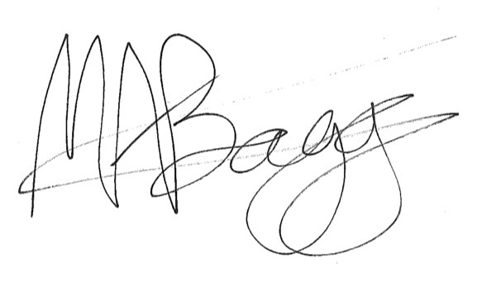
Dr Melanie Bagg
Chief Executive Officer

